**Batch: H2-3 Roll No.: 16010122221**

**Experiment 07**

**Title: To create an effective Dashboard in Tableau.**

**Objective:**

1. *Search/locate and download any Data of Your Choice (Use same dataset if it contains location information)*
2. *To learn how to create Dashboard in Tableau 3. Apply best practices to create Tableau Dashboard.*

**Course Outcome:**

CO1: Learn how to locate and download datasets, extract insights from that data and present their findings in a variety of different formats.

CO3 Create compelling, interactive dashboards to combine several visualizations into a cohesive and functional whole.

**Books/ Journals/ Websites referred:**

1. Data Visualization made simple New York: Routledge - Kristen Sosulski, First edition, 2019
2. Sosulski, K. Data Visualization Made Simple: Insights into Becoming Visual, First edition, 2018
3. <https://www.kaggle.com/uciml/adult-census-income>
4. <https://archive.ics.uci.edu/ml/datasets/adult>
5. https://ori.hhs.gov/education/products/n_illinois_u/datamanagement/dctopic.ht ml
6. A review of research process, data collection and analysis - Surya Raj Niraula

**Resources used:**

1. https://www.kaggle.com/uciml/adult-census-income
2. https://archive.ics.uci.edu/ml/datasets/adult

**Theory:**

A dashboard is a collection of several views, letting you compare a variety of data simultaneously. For example, if you have a set of views that you review every day, you can create a dashboard that displays all the views at once, rather than navigate to separate worksheets.

Like worksheets, you access dashboards from tabs at the bottom of a workbook. Data in sheets and dashboards is connected; when you modify a sheet, any dashboards containing it change, and vice versa. Both sheets and dashboards update with the latest available data from the data source. Each view you add to the dashboard is connected to its corresponding worksheet. So when you modify the worksheet, the dashboard is updated and when you modify the view in the dashboard, the worksheet is updated.

Individual worksheets in Tableau can lead to powerful insights that help your business, but many times, it makes sense to combine the worksheets into a single dashboard. By combining varying visualizations into a dashboard, you and your audience are able to analyze different aspects of the data in context of each other. This is a much more intuitive experience than viewing the visualizations individually.

In addition to this one obvious benefit, Tableau comes with several technical features that allow you to control the user experience and even the ability to have the individual components of the dashboard interact with each other. This post offers an introduction to dashboards in Tableau and several ways to share the dashboard after it has been created.

A good business dashboard informs with a glance. A great business dashboard combines high performance and ease of use to let anybody get data-driven answers to their deeper questions. Building dashboards with Tableau allows even non-technical users to create interactive, real-time visualizations in minutes.

Using dashboards to tell a story can create impact and evoke emotion, helping to move people, and make decisions.

In just a few clicks, they can combine data sources, add filters, and drill down into specific information. Sharing a dashboard requires no programming, whether it’s on Tableau Server, Tableau Online, or any portal or web page.

**Following points should be written by students**

1. Best practices of effective Dashboard.

A well-designed dashboard can align your organization's efforts, help uncover key insights, and speed up decision-making.

* Know your purpose and audience: The best visualizations have a clear purpose and work for their intended audience. In addition to knowing what you're trying to say, it's important to know who you're saying it to.
* Design for the real world: Author at your final display size. By default, Tableau dashboards are set to use a fixed size and if you keep this setting, be sure to construct your visualization at the size it will be viewed at.
* Limit the number of views: In general, it's a good idea to limit the number of views you include in your dashboard to two or three. If you add too many views, visual clarity and the big picture can get lost in the details. If you find that the scope of your story needs to grow beyond two or three views, you can always create more dashboards.
* Add interactivity to encourage exploration: Show filters. Filters help users specify which data is shown in the view. You can customize each filter for different types of data. You can also edit the title of a filter to give your viewers clear instructions for interacting with the data.
* Enable highlighting: You can use the Highlight button on the toolbar to set up highlighting between views. When highlighting is turned on, a selection in one view will highlight related data in the other views. You can turn on highlighting for all fields or select specific fields.

1. Create Dashboard.

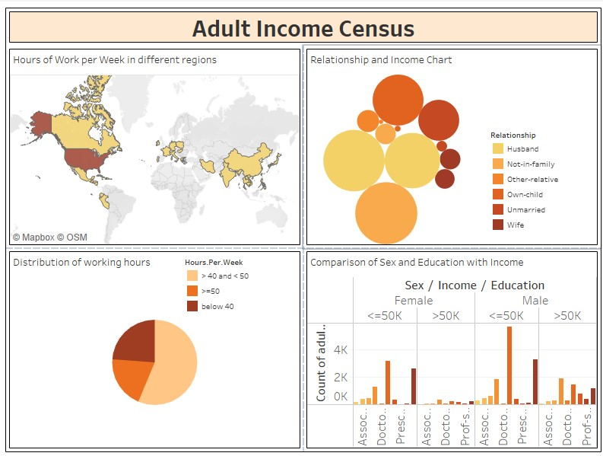

For this particular experiment, we have created a dashboard on the Adult Income Census. This dataset is from 1994 Census database. We have shown comparison of income on basis of working hours, relationships, education and gender. We have added borders and followed a particular color scheme to make the dashboard more visually appeasing. Through this dashboard we try to analyze the income level based on external factors and predict the income of a population.

1. Create Accessible Dashboard.

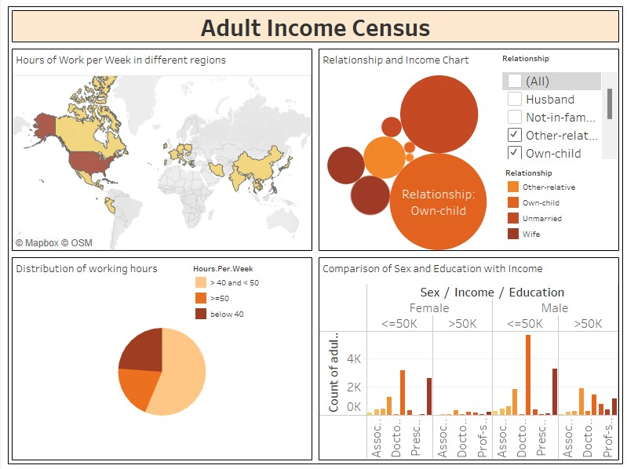

To make the dashboard more accessible we have added filters and captions. We have even provided different views so that viewing is comfortable in various devices. Tableau Desktop can be used to make a more accessible dashboard.Many items and objects in the Tableau workspace support keyboard navigation and are compatible with assistive technologies like screen reading software. You can use the following items on a dashboard you want to be accessible.

This dashboard has a color scheme, formatting, filter options and a title to make it more accessible.

1. Create Dashboard Layouts for Different Device Types.

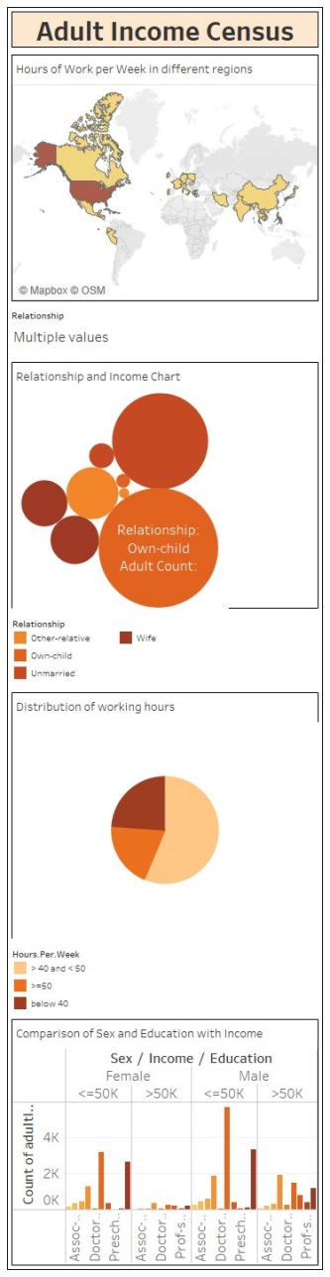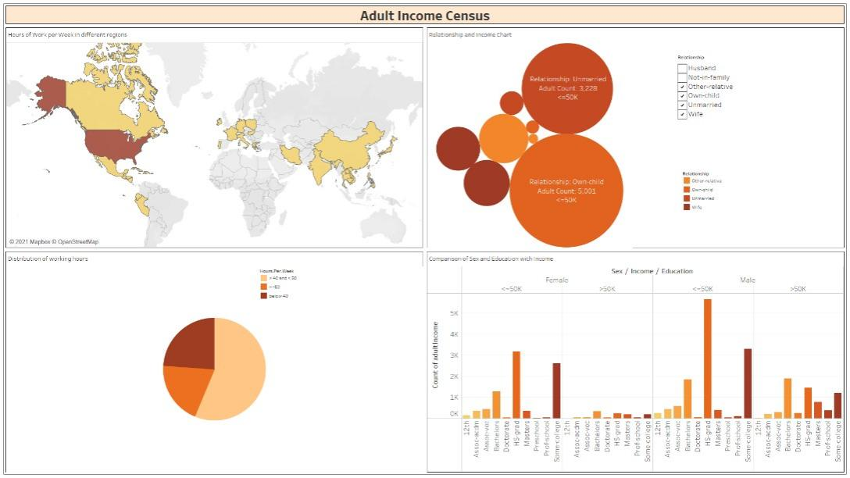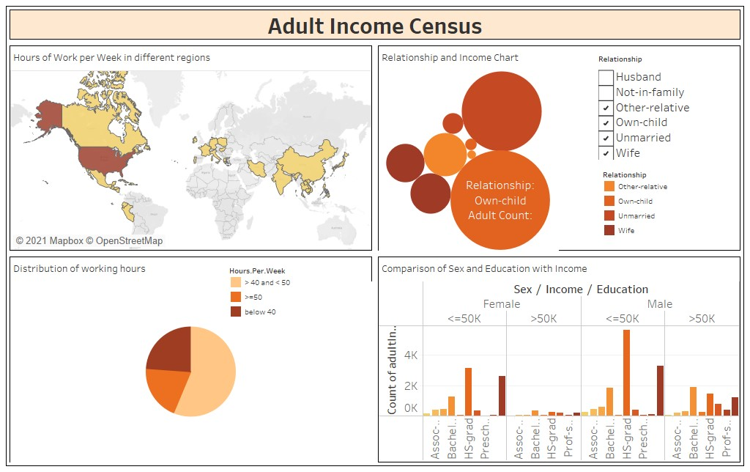

As we can see in the screenshots above, we have tried different layouts of the dashboard such that it can be comfortably viewed in a tablet, desktop and a mobile.Dashboards can include layouts for different types of devices that span a wide range of screen sizes. When you publish these layouts to Tableau Server or Tableau Online, people viewing your dashboard experience a design optimized for their phone, tablet, or desktop.

**Conclusion:**

Through this experiment we created a visually appeasing dashboard with respect to our problem statement. We tried to combine different sheets and change layouts to make the dashboard more accessible and give a clear analysis.

**Date: 17-11-2021 Signature of faculty in-charge**

**Post Lab Question:**

**1. Explain the Advantages and Disadvantages of Dashboard**

Advantages:

* Customizable.– Dashboards could be customized in terms of users and expectations. Each decision level dashboard can be customized to present the most valuable and useful set of information. This allows each person to see the level of detail that they need in order to get their job done and meet their goals.
* All-in-one.- In the past users would spend large amount of time reviewing and analyzing different reports to end in a final conclusion. This tool allows to see, at a glance, an overall situation report of the desired information.
* Drill into detail.- But, having all-in-one does not means the absence of details. Dashboards are developed with the ability to get as deeper in information as required by simply selecting the desired variable or object.
* Intuitive data presentation.- There is no need for complicated and exhaustive training. Dashboards are design to be intuitive to any user. The graphic design allows an easy and smooth navigation throughout the information.
* Mobile device accessible.- Most dashboards software are programmed to suit any mobile device. The idea is to reach anywhere, to everyone, in a timely manner with the most accurate information.

Disadvantages:

* **Dashboard reporting needs meaningful metrics:** First and foremost, a dashboard must measure something meaningful. This requires an understanding of the right metrics to select.
* **Businesses should set up dashboard reporting with a specific user in mind:** Dashboards are often set up without a user in mind. This can be problematic from the very beginning, as specific software is designed for experienced developers, making them highly complicated to set up by anyone outside of an IT department.
* **Compatibility and interfacing issues:** Data is not universal. Connectivity and compatibility is a common challenge among business dashboards. To bridge the gap, users have to manually input data, which essentially defeats the purpose of the dashboard.
* **Scalability and cost:** Dashboards can be costly depending on the provider’s requirements and the size of the business. Some providers require a license for each individual that will be accessing the dashboard.